Week 5 Assignment

By

Ujjwal Bhasin - 200389272

RELATIONAL DATABASES

PROF. MAZIAR

PART I

1. Create “Assignment” database, and create a table with ‘Brand’, ’Model’, ‘Price’, ‘RAM’, ‘Hard Disk’, and ‘Description’ columns in your table. The Table’s name must be ‘computers’.

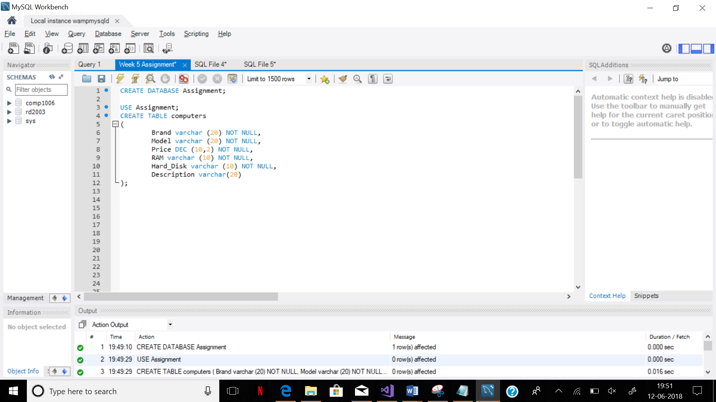

2. Open the Best Buy website

<https://www.bestbuy.ca/en-ca/category/laptops-macbooks/20352.aspx?>

And find 20 laptops (Price ranges between 400 and 2500 CAD). Insert 20 rows to your table using the website’s information.

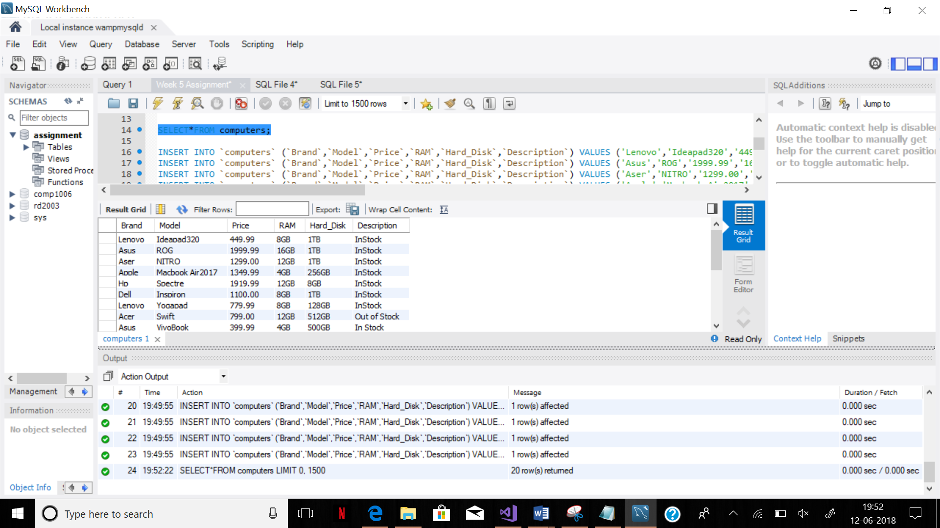

3. We are going to buy a laptop, and we have 950 CAD. Write a query to show all computers between 700 and 950.

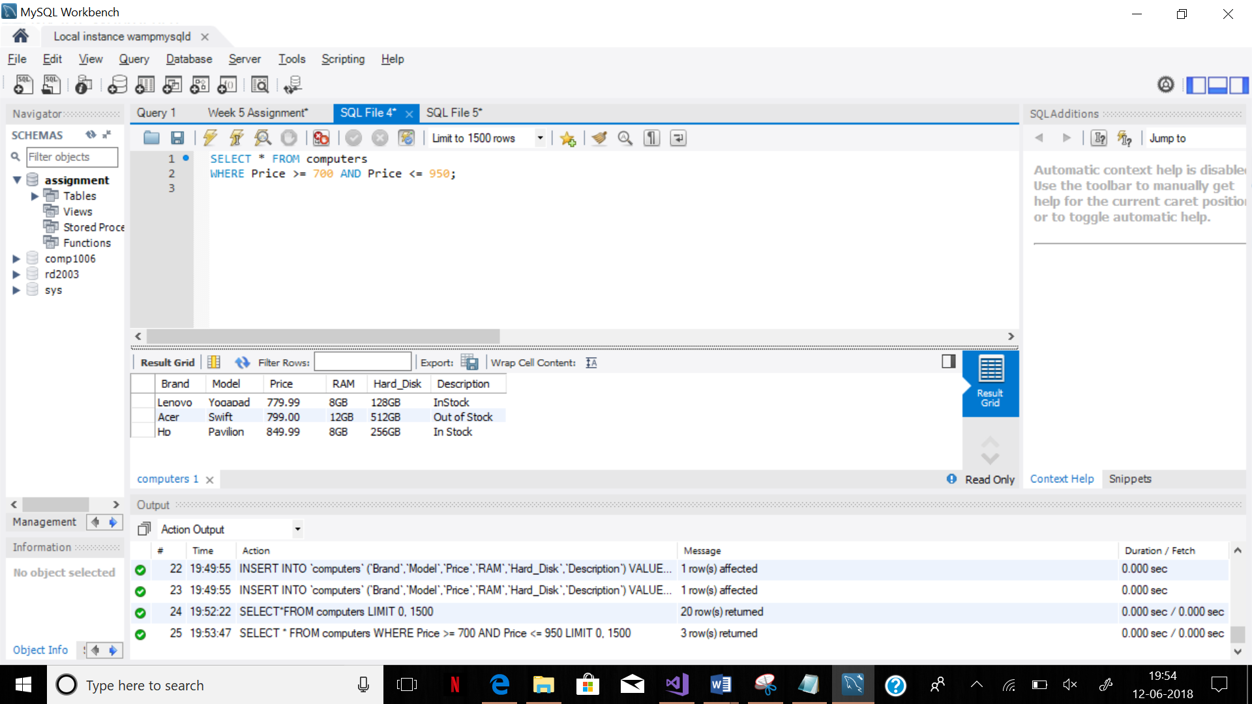

4. We need also to see all ‘Dell’, ‘Acer’, and ‘Lenovo’ laptops. (Use IN to write the query).

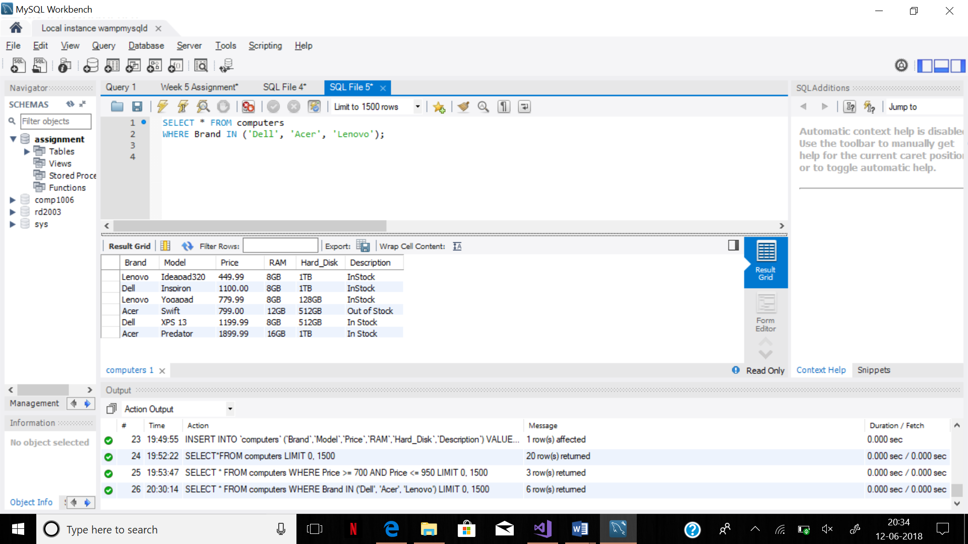

5. Delete all computers with prices greater than 1500 CAD and show the remained computers in our table.

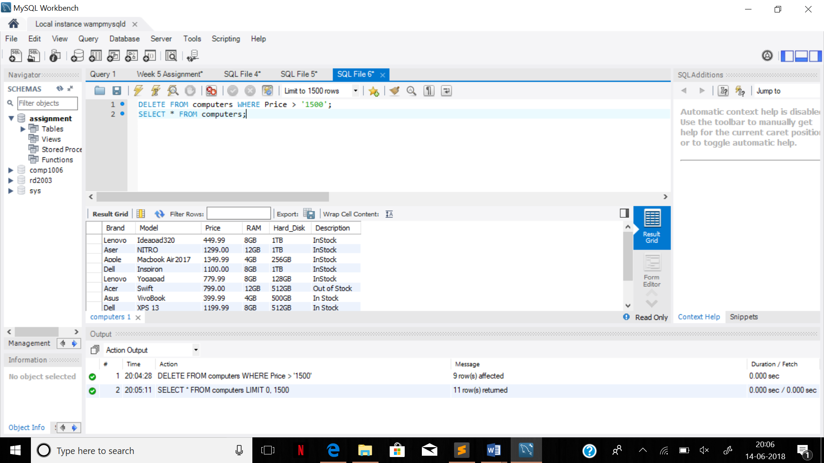

6. We need to add 4GB of RAM to all computer which have 8GB. Write a query to update the table. Test your query by trying to retrieve all laptops with 8GB of RAM.

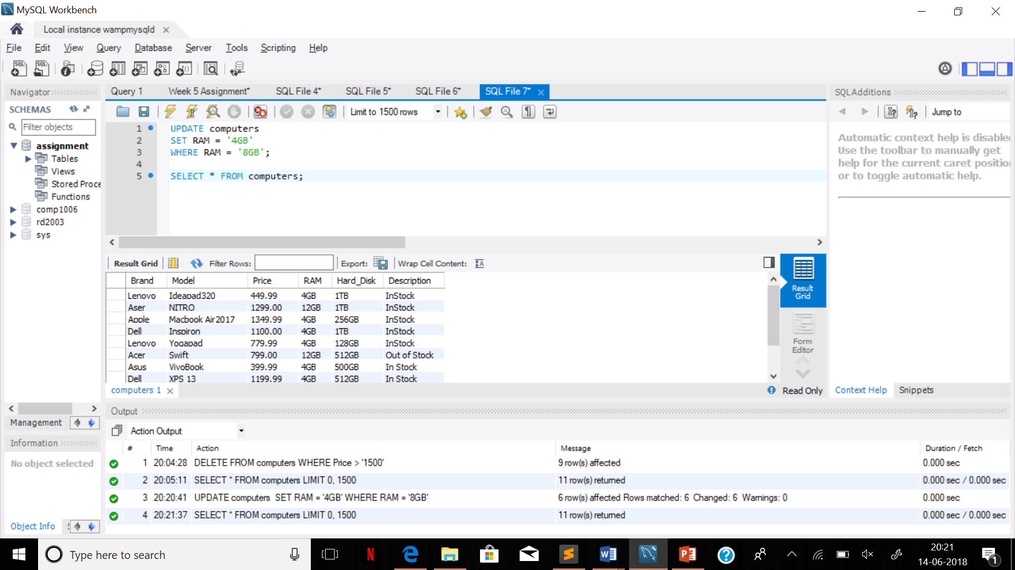

7. Our table needs a primary key. Add ‘ComID’ to the table as primary key (as the first column) and make it auto increment. Also, add ‘Screen_Size’ after the ‘Model’ column in your table (insert 14” for all laptops).

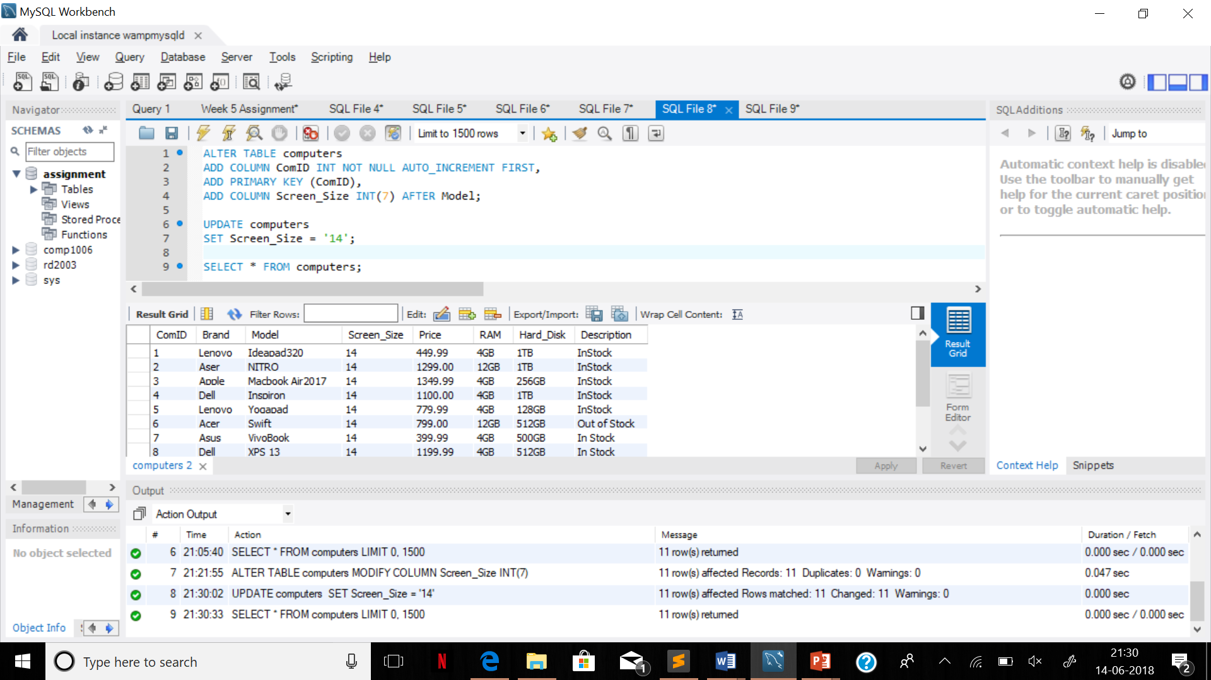

8-Change the table name to ‘Com_Table’. Change the name of ‘Price’ column to ‘Com_Price’. The ‘Description’ column must be able to store 55 characters. Change the data type of ‘Description’ column. Try to use only **one** command for all the changes.

Use Describe command to show the structure of your table.

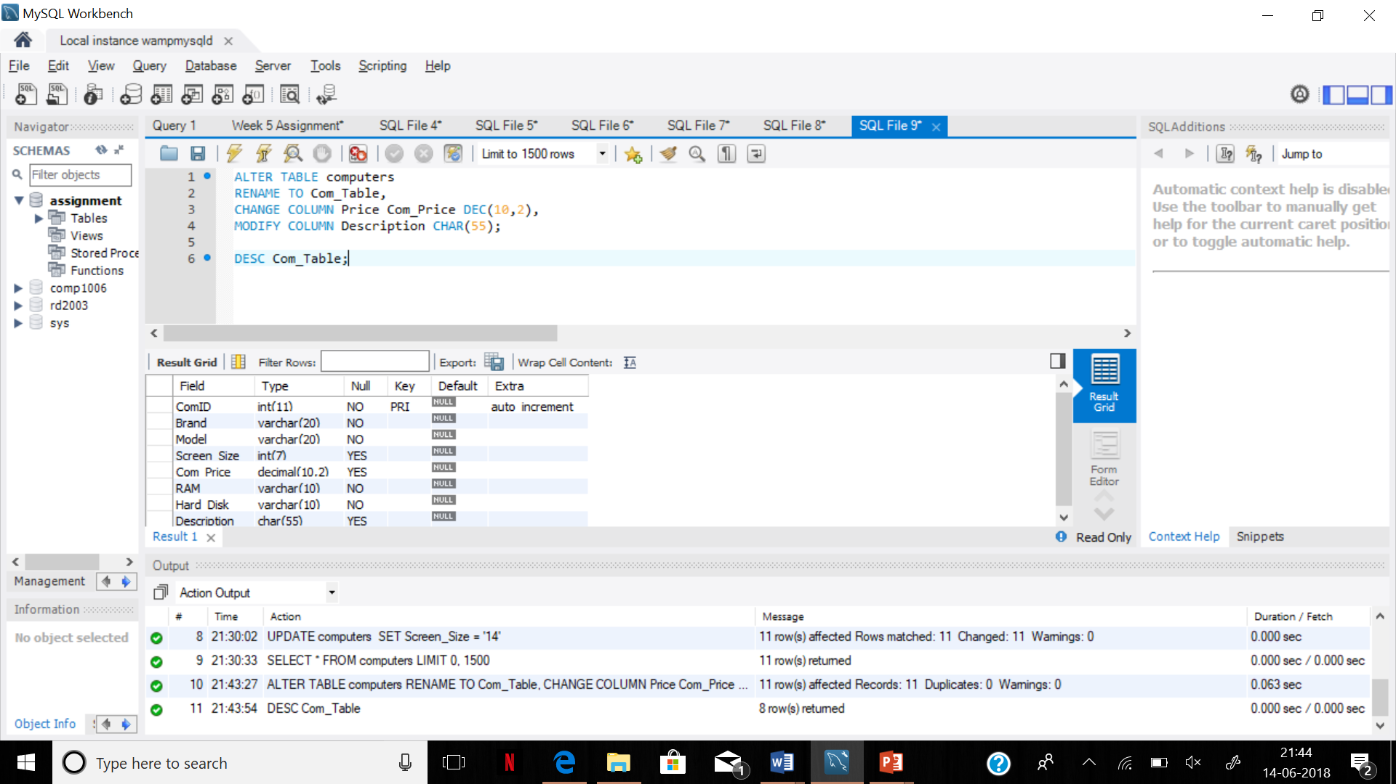

PART II

1. Show the full name, gender, and the location of all customers.

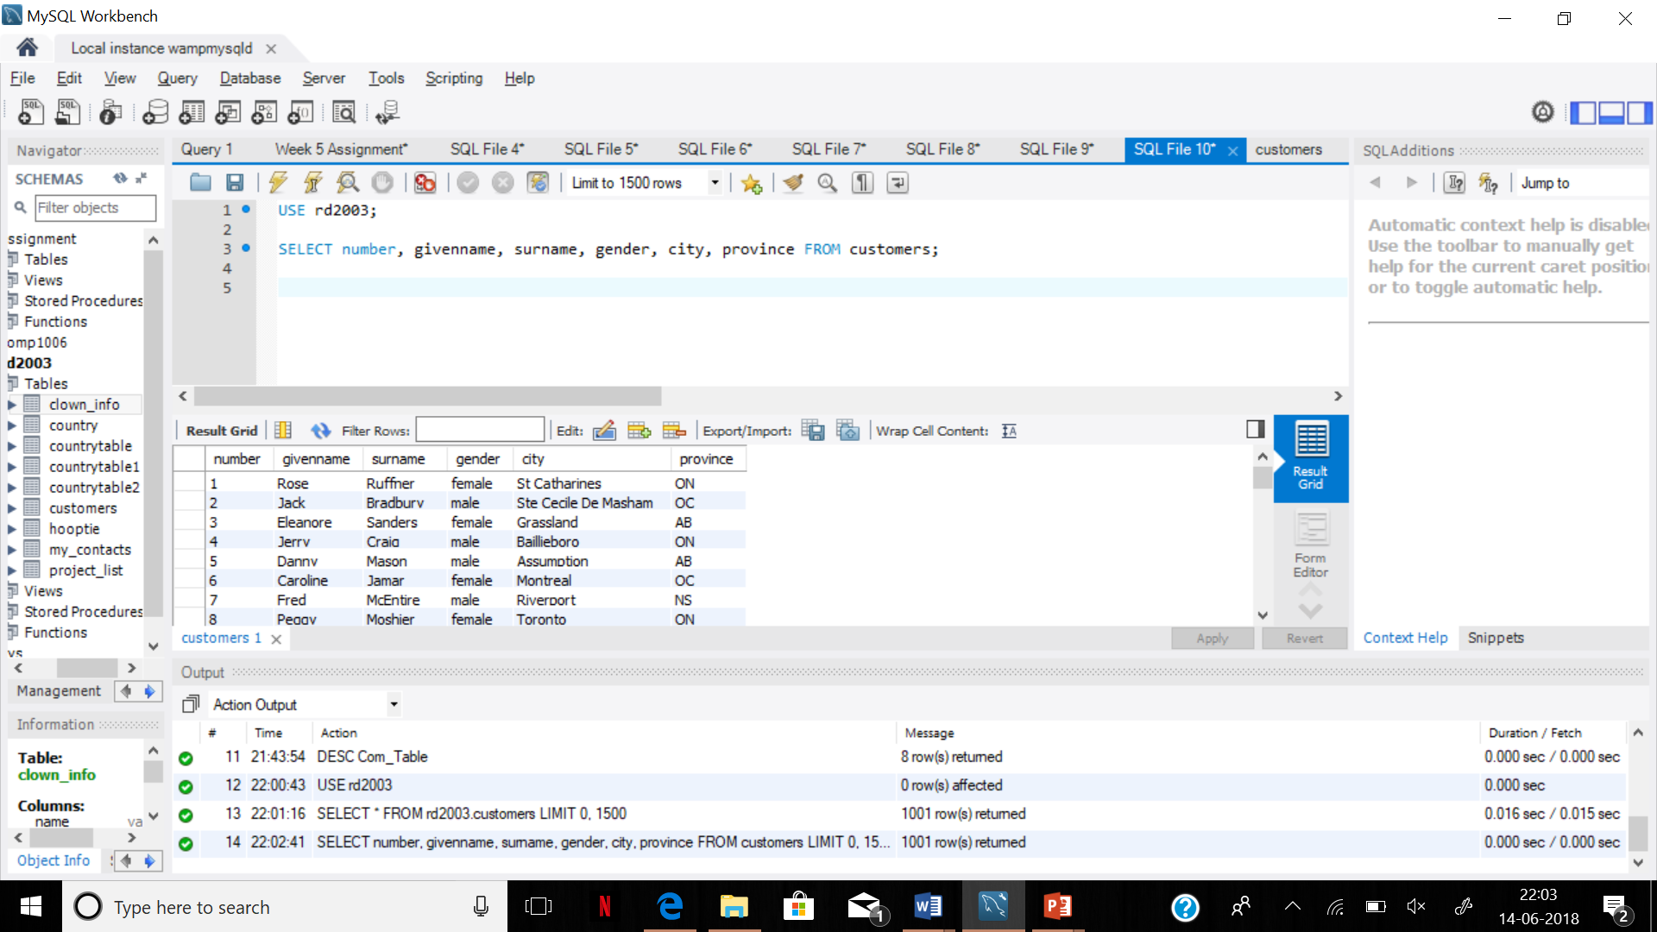2. Write a query to show all customers who live in ‘Keene’ and have ‘k0’ [k-zero] in their postal code.

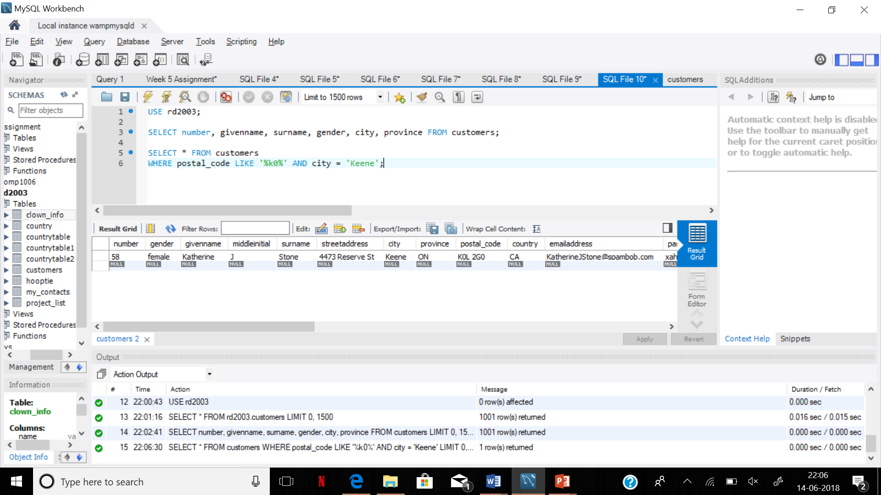

3. Add a column to the customer table. The name of the column has to be ‘UserID’ and data type is varchar (10). The column must be before ‘password’.

Now it is time to fill the ‘UserID’ with the first **uppercase** 4 characters of Surname.

